**Consider the activity list in the table below.  All duration estimates or estimated times are in days.**

1. **Draw an AOA network diagram representing the project.  The network should proceed from Node 1 to Node 9.  Put the node numbers in circles and draw arrows from node to node, labeling each arrow with the activity letter and estimated time.**
2. **Identify all of the paths on the network diagram and note how long they are.**
3. **What is the critical path for this project and how long is it?**
4. **What is the shortest possible time needed to complete this project?**

|  |  |  |  |
| --- | --- | --- | --- |
| **Activity** | **Initial Node** | **Final Node** | **Estimated Duration** |
| **A** | **1** | **2** | **1** |
| **B** | **2** | **3** | **3** |
| **C** | **2** | **4** | **1** |
| **D** | **2** | **5** | **2** |
| **E** | **3** | **6** | **2** |
| **F** | **4** | **6** | **4** |
| **G** | **5** | **7** | **3** |
| **H** | **6** | **8** | **3** |
| **I** | **6** | **7** | **1** |
| **J** | **7** | **8** | **7** |
| **K** | **8** | **9** | **4** |

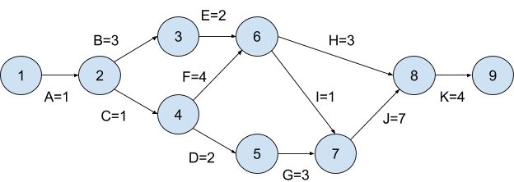

A-D-G-J-K length: 17  
A-B-E-I-J-K length: 18  
A-B-E-H-K length: 13  
A-C-F-H-K length: 13  
A-C-F-I-J-K length: 18

Critical Path: A-C-F-I-J-K

Shortest Path (length): 13 days